**Culinary Solutions**

Final Term Project – 2021 Fall - IT STRATEGY 22:544:670

**Group 7:**Anshul Jaiswal   
Devendra Shankar Gaud

Harsh Pratap Singh

Shrutee Verma

Yashasvi Sharma

**Contents:**

Business Model…………………………………………...3

IT Strategy: Technology Setup and Structure……….........3

Porter's Five Forces

Rivalry among Existing Competitors……………….5  
 The threat of substitute………………………………5

The power of suppliers……………………………...5

The power of buyers………………………………...6

Threat of Entry………………………………………6

Seven Barriers………….…………………………………...6

Cost and Revenue model……………………………………8

Initial Marketing Plan and Launch Strategy………………..11

References………………………………………………….14

**Culinary Solutions**The platform will provide an app for the users to sign up, view a particular cuisine, a recipe of a dish that a user wants, and most importantly, if the user wants to get the ingredients of that dish, the app will suggest the nearby stores the user can get the ingredients from. In the initial stage, the app will be free. The business will start to make money when we get a good number of users signed up, and we will contact the nearby stores that need to get sponsorship for the app.

**Business Model:**  
Now, we will talk about the business model? There will be two stakeholders in the ecosystem i.e.,   
a) Users: Who wants to see the nearest stores where they can get the ingredients for the recipe by turning on the location of their device. Each user will have an option to sign up and look for a particular cuisine they are looking for in the app. After looking at the recipe, the customer will have an option to see where he can get the specific ingredients used in the recipe nearest to them.  
b) Stores: The stores will be featured in the app and know what they need to have in store. The elements considered while designing the basic structure will be (1) Store owner’s background check (2) Store License. As our ecosystem evolves, we will take into consideration the ratings and reviews of the stores as one of the crucial parameters for re-examining the compensation structure.  
  
Currently, no such app provides this feature of showing nearby places where the user can go and buy the ingredients. There are apps where you can go and order whatever grocery you want, but no such app will tell you the exact ingredients needed and where to get it.  
  
Our product aims to save the user's time by directly looking on the app what all ingredients the particular dish requires and where they can get it from.  
  
**IT Strategy: Technology Setup and Structure**“Culinary Solutions” is a mobile-based app. The app acts as a medium between a user and a store where users can browse different cuisines, select a particular dish, and get a list of ingredients. The background checks will be performed for the store owners before their accounts are approved on the app (this will be implemented at a later stage) . The company will host the platform on Amazon Web Services (AWS), which is a cloud-based database service operated by Amazon and is metered on pay-as-you-go. There are many services which Amazon provides, and here it will be responsible for:

* Amazon management console
* Technology platform, Amazon EC2 (Elastic Compute Cloud)
* Mobile app
* [AWS Identity & Access Management (IAM)](https://aws.amazon.com/iam/?c=sc&sec=srv)  
   - securely manage access to services and resources  
   - specify who can access which services and resources and under which conditions
* Platform validation and testing for functionality and security
* A partnership with YouTube for videos of recipes
* The platform incorporated, i.e., Amazon Web Services, will be responsible for the integration of YouTube links of the recipes in the app
* We will also be providing a 24/7 help desk through a chatbot on the app, which will give every kind of help required by the user

**Porter's Five Forces**

Porter's Five Forces is a business analysis model that helps to explain why various industries can sustain different levels of profitability. The key to successful business strategy is an effective defence against the competitive forces and shaping them in a company's favour.

For "Culinary Solutions," the analysis of Porter's Five Forces goes as follows:

**Rivalry among Existing Competitors**

The Idea of Culinary Solutions is Unique in the market as far as the Current Scenario is concerned. To face competition and gain popularity in the market, recurring improvements in the idea keeping in mind the user-friendly environment and regular customer feedback, will be the most excellent resources. Providing the most effective and accurate descriptions of the recipes and the places to gather the ingredients with ease is the method to provide a user-friendly environment for the customers. The quality of the service offered by the idea is a significant factor for the customers to seek attraction towards the vision. Providing the customers worldwide connecting them to various tastes of different cultures and the effectiveness of getting the ingredients to help them prepare those tastes in their stays is where we can win the customer satisfaction and trust in the idea.

**The Threat of Substitute**

Initially, the idea may not face much competition in the industry. At the same time, in this world of ever-growing information technological aspects, It would not take much time for the idea to face the threat of substitutes. As a result, preparing future goals to sustain in the industry is a much important aspect to be looked upon. Also, gaining the customers' trust by providing information about ingredients at the most accurate and legitimate cost is a factor that will give the success of the idea among substitutes. Advertising about the concept in the right market by word of mouth simultaneously through various online and offline factors provides a way to stand different among the substitutes. Also, giving various profits in terms of coupons, cashback, and offers is an effective way to gain attention in the customers' minds.

**The Power of Suppliers**

When talking about providing the ingredients and products at different locations of the tastes and recipes from various cultures and places, Suppliers of the components would play a massive role in the idea's effectiveness. This is what we are referring to the power of suppliers. Providing the best product quality at a very economical price is a must for the supplier to get the product popularized in the market and gain greater profits and growth. No wonder the quality of materials varies from geographical locations, and transportation plays an essential role in capturing the market for the product is in the hands of the suppliers.

**The Power of Buyers**

The buyers' market in this scenario of Culinary Solutions may vary from region to region. The area with many customers will result in a lower power in the hands of customers to negotiate in terms of price and better offers. On the other hand, regions with fewer customers will provide customers with greater power to negotiate for lower prices and deals. This also depends on the status of the customers as affluent customers would not usually arrange for the cost of the items and look for more outstanding quality. In contrast, the middle class would look for prices rather than the quality of the product. These are the factors that should be utilized to provide the products in various regions to provide popularity among the buyers.

**Threat of Entry**

The threat of entry is explicitly provided when an already established company from other markets would step into this market, providing tremendous pressure on the company for lower prices and filling up existing flaws that will influence the competition for the company. The various factors responsible for the threat of entry are categorized into Seven barriers of entry.

The Seven Barriers of Entry for the Culinary Solutions include:

1. Supply side economy of scale:

Producing the ingredients for various recipes and their popularity in the region would help gain higher profits by manufacturing higher quantities for reduced cost per product.

2. Demand-side benefits of scale:

These benefits increase sales as the demand increases due to higher availability and easy access to the customers. This could be enhanced with the help of delivering products at the doorsteps using various online platforms and delivery partners.

3. Customer switching cost:

This is a result of customers getting a better substitute for the same service at an economical price or with some more effective service. Constant monitoring substitutes of the service and urge to keep up with the flaws in the system and service is the fundamental solution to this barrier.

4. Capital requirements:

The Capital requirements barrier would not be such an issue for the culinary solutions as it acts as an intermediator between the customers and the supplier for the ingredients. Hence, the capital investments are liable to the service provided and the maintenance of the system with regular check-ups for problems and solving them as soon as possible.

5. Incumbency (leader) advantages independent of size:

The incumbency advantages are liable to some ingredients which are a part of the regular recipes of the regions or some substitute that the customers would adapt to increase the richness of the taste. The cost and quality are the factors to consider for this barrier.

6. Unequal access to distribution channels

Customers' entrance to the idea is with the help of proper awareness about the product in the market via advertisements and words of mouth among customers. Investing a particular amount and among appropriate markets is necessary to cope with this barrier of entry.

7. Restrictive government policy

The government policies may directly affect the culinary solutions as restrictions for transportation and availability of various ingredients in different regions may create a barrier. Still, also subsidies and favourable policies could boost up the idea immensely.

**Cost and Revenue model**   
  
Before creating the mobile application, you need to analyze the target audience and business objectives, understand how to develop an app, and choose a platform to code.  
The buttons, screens, and other elements make the application unique, engaging, and convenient, but each additional piece affects the overall project budget.

Therefore, a protype is created and think about the over functionality to the minute detail.

How much it cost to build an app depends on three things –

1. The application’s complexity level
2. Design and Structure
3. The platform on which the application will run

There are three types of complex levels and we choose to go forward with the mid level apps which includes – integration with the API such as GPS which can help us in the location of the ingredients. More screens, custom UI and features like real time messaging.   
  
**Mid-level apps** take around 6-10 months to be developed.   
In these applications, you are looking to add some extra features than the simple apps (other than the ones you find above)

* Social Media Integration
* Geo-location
* Location Tracking
* Better Security

The cost of building an app range from $10,000 to $150,000 and depends on app complexity.

|  |  |  |
| --- | --- | --- |
| Basic Mid - level App Development | $60,000 to $150,000 | 6-9 months |

We’ve chosen an entire expert development team for our project:

* a project manager,
* a UI/UX designer,
* iOS or/and Android developer,
* a backend developer,
* and a QA engineer,

Therefore, we’ve decided to work with free lancers which can cost us -

|  |  |
| --- | --- |
| **Criteria** | **Description** |
| Cost | There are two ways you can go ahead with a freelancer.   * Hire them on a contract basis * Hire them on an hourly basis   Plus, there are plenty of platforms to find freelancers.  Websites like Upwork, Fiverr, PeoplePerHour, Toptal, and so on.  The average hourly price of a freelancer again depends on the country you are hiring from.   * US: $50 per hour * Asia: $15 to $25/hour * Ukraine: $25/hour * Latin America: $20/hour   These are the starting rates, and they can climb as per the experience.  So, to figure out the cost to build a useful and excellent app, consider the hours. |

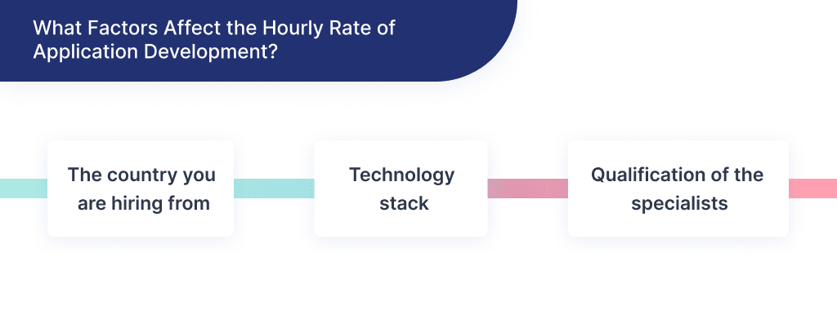

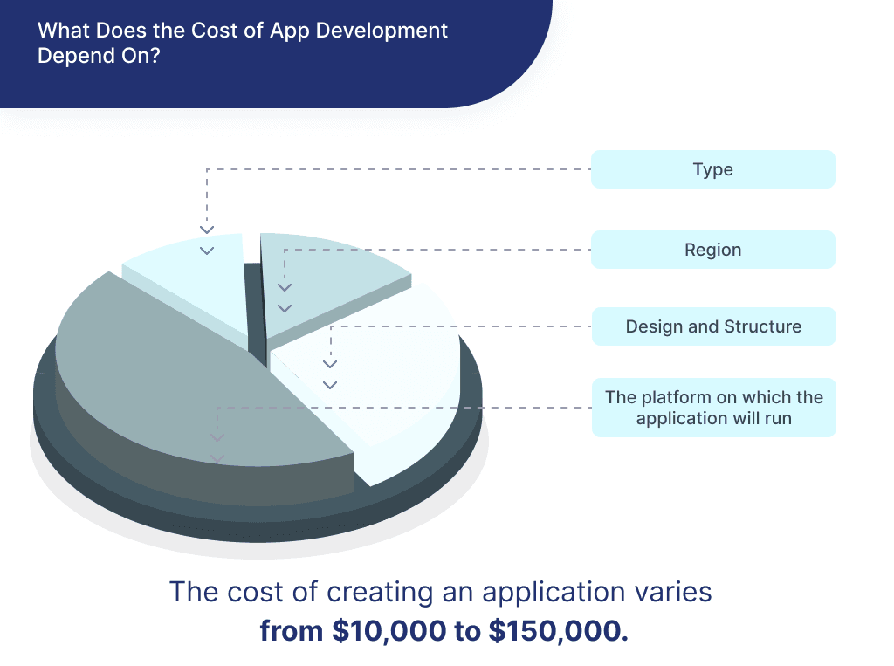

**Generating Revenue**

How Culinary Solution works is: First, users must download the app and create an account. Once signed up, users can then select different region or search bar option and accordingly select the dish which is to be recreated. Our app will use the GPS location and help the user with the ingredients which is located closest to location.

Since the App would be free in its initial stage, we rely on Angel investors, several funding and while offering **Premium subscription** to our users and **In-app Advertisement.**

|  |  |  |  |  |  |
| --- | --- | --- | --- | --- | --- |
| Financial Projections for first 5 years | | | | | |
| Financial year | Dec 22 to  Nov 23 | Dec 23 to  Nov 24 | Dec 24 to  Nov 25 | Dec 2025  to Nov 2026 | Dec to Nov 2026-27 |
| **Revenue - See above (Section: Business Model)** | | | | | |
| **IT Cost - See above (Section: Business Model)** | | | | | |
| **Other Operating Expenses** | | | | | |
| Sales & Marketing | 0.25 MM | 0.5 MM | 1 MM | 2 MM | 3 MM |
| General Expenses | 30k | 50k | 70k | 90K | 110k |

**Initial Marketing Plan and Launch Strategy:**

Our business is just getting started & launching a new product into the market is the beginning of a journey without any pre-determined destination.

*And That Is Why We Need A Marketing Plan!!*

It is necessary to the success of our business to know where we want to take it in the future. And the only way we can get there is to have a roadmap or plan to help us guide the journey. Consider your marketing plan the roadmap to our business future. To introduce our product to the world is by creating an application which contains all the relevant information about our product. X

For our product to reach the right set of audience and set an impression on their first interaction, we must follow some steps mentioned below:

**1. Organizing a Pre-Launch Giveaway:**

For our application to take off quickly, we need to make a sensation of assumption and fervour for its delivery beginning weeks or even a very long time ahead of time.

We would use one of the most popular techniques to do this is through pre-launch giveaways and contests. We will give a special discount to an exclusive group of lucky customers, in exchange for them helping to get the word out. There are several options: Instagram contests, YouTube promotion giveaways, etc. We could try to initiate or create content or ideas which eventually assist our product with circulating around the web. For instance, make users share their support on their social media or concoct a decent TikTok or Instagram Reel challenge & then we will provide them special offers.

**2. Relationships Establishment with Social Media Influencers:**

The influencers are the kings and queens of social media marketing. They usually have loyal audiences, waiting and willing to follow their recommendations as experts in a given area or industry. This influencer marketing is the digital version of word-of-mouth marketing.

To get bloggers and influencers talking about our brand, we will organize events and provide them with free subscriptions. There are millions of watching for many famous Chefs like Salt Bae on YouTube, Rumble, and even on TikTok. These promotions with special offers will surely attract the audience to try and avail offers.

We could try to be creative in our messages to make sure people do not look at it as spam and offer extra points for bringing in friends.

**3. Increase in Organic Visibility:**

For this, our SEO Search Engine Optimization) needs to be on point. Having a well-positioned application or website on search engines gives steady traffic to show our new product much better than starting from square one.

For search engine optimization to work, we need to give our users information that would be useful. We will focus on optimizing three areas:

* Brand Name: Our main aim is not about what we call or describe our product but rather how new users search for it, but rather how new users search for it. Therefore, the name would be according to that. The Simpler, The Better, The Catchier it is.
* Meta Descriptions: Meta descriptions need to be short and attractive.

*Meta descriptions are the summary of our web page on search engines.*

* Initial Read: The goal is to make sure readers know and understand the product in the least amount of reading time possible.

**4. Amazon Ads:**

We can use relevant ads to reach the audience and allow them to redirect to the main application or website to explore options.

*Amazon Ads are available to businesses of all sizes and accessible to marketers of every level of expertise. Amazon Ads provides ad solutions that help your business connect with customers at every stage of their journey. Amazon has a deep understanding of how customers engage with products and brands to discover, research, and purchase online.*

**5. Email Marketing:**

To effectively implement an email marketing strategy, we will first create a database with your clients. We will collect information for our clients (with their consent) such as age, name, location, and mainly, previous purchases or products they have shown interest in the past.

Then Use this information to create a highly personalized messaging strategy. We will make the users feel like the emails have been written specifically for them. We will use Marketing automation as it inefficiently manages all this information.

**6. Soft Launching the Product:**

Starting on the right foot will be the most step for any start-up. To dispatch the product, we would search for Angle Investors who could help launch our product with their investment. These expenditures will cover our pre-launch and then product release activities. To pitch the above ideas will be soft launching the prototype with a Beta version. Based on the success of the Soft-Launch, we will make improvements to the product for the final Launch.

To Soft-Launch the product, we would set up a pre-registration page for our users, which we earned because of our Initial Marketing Plans. It will give us a brief idea of the number of users interested in the upcoming app. Providing early access to such users will help us understand the requirements or needs of the users. If pre-registration signup is successful, it is a sign that the Launch strategy might work. The process of Pre-launch will also help us understand the technical issues in our app like bugs in the application, logical flaws in the algorithm, if any, applications' response to the user's request.

**7. Optimizing Application Speed:**

We will make sure that our application runs at full speed as it is very frustrating if an application takes hours to load. A quick and fluid application improves user experience and brand perception. And Optimizing application speed is a trick that is as simple as it is effective.

There are several things we will do to improve our application loading times, for that we will hire an expert (Full Stack developer). During this time, we will make sure that all the images are of a high enough quality, but not massive; else, it will slow down the application.

**8. Launching the Final Product:**

Following the soft-launch response, we will improve our application and can finally launch it on App Store and Google Playstore platforms. We will launch this application in a Live Event on social network sites like Facebook, Instagram, Reddit, etc. that will be an ideal kickstart. The application is demonstrated via a video explaining all the features of the application on the various marketing platforms used previously.

We’ll be performing post launch activities such as monitoring users’ feedbacks & review, making updates/fixes as and when required.

**REFERENCES**  
  
1. <https://www.g2.com/articles/how-much-does-it-cost-to-make-an-app>

2. <https://entrepreneur-360.com/how-does-splitwise-make-money-24732>

3. <https://topdigital.agency/soft-launch-steps-you-have-to-know-in-2021/>

4. <https://clevertap.com/blog/product-launch/>

5. <https://www.cyberclick.net/numericalblogen/10-marketing-strategies-for-your-product-launch>

6. <https://advertising.amazon.com/en-us/lp/build-your-business-with-amazon-advertising>